URDF INAIL 2 ARM

BASE (Link 0)

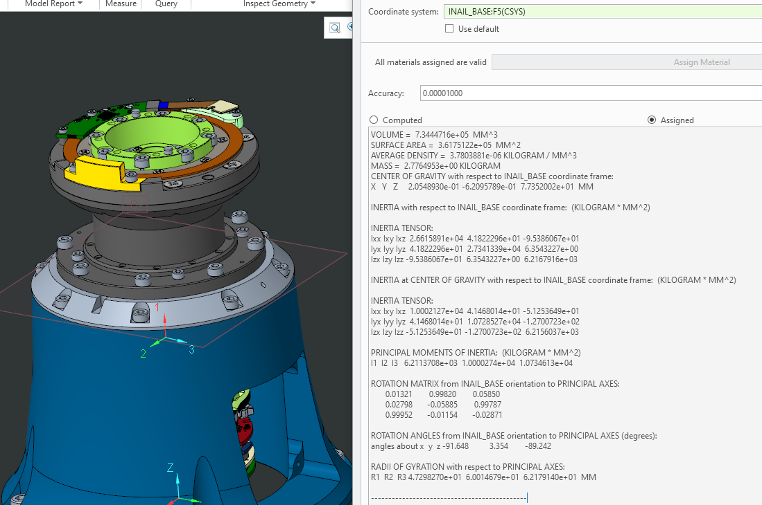

VOLUME = 7.3444716e+05 MM^3

SURFACE AREA = 3.6175122e+05 MM^2

AVERAGE DENSITY = 3.7803881e-06 KILOGRAM / MM^3

MASS = 2.7764953e+00 KILOGRAM

CENTER OF GRAVITY with respect to INAIL_BASE coordinate frame:

X Y Z 2.0548930e-01 -6.2095789e-01 7.7352002e+01 MM

INERTIA with respect to INAIL_BASE coordinate frame: (KILOGRAM * MM^2)

INERTIA TENSOR:

Ixx Ixy Ixz 2.6615891e+04 4.1822296e+01 -9.5386067e+01

Iyx Iyy Iyz 4.1822296e+01 2.7341339e+04 6.3543227e+00

Izx Izy Izz -9.5386067e+01 6.3543227e+00 6.2167916e+03

INERTIA at CENTER OF GRAVITY with respect to INAIL_BASE coordinate frame: (KILOGRAM * MM^2)

INERTIA TENSOR:

Ixx Ixy Ixz 1.0002127e+04 4.1468014e+01 -5.1253649e+01

Iyx Iyy Iyz 4.1468014e+01 1.0728527e+04 -1.2700723e+02

Izx Izy Izz -5.1253649e+01 -1.2700723e+02 6.2156037e+03

PRINCIPAL MOMENTS OF INERTIA: (KILOGRAM * MM^2)

I1 I2 I3 6.2113708e+03 1.0000274e+04 1.0734613e+04

ROTATION MATRIX from INAIL_BASE orientation to PRINCIPAL AXES:

0.01321 0.99820 0.05850

0.02798 -0.05885 0.99787

0.99952 -0.01154 -0.02871

ROTATION ANGLES from INAIL_BASE orientation to PRINCIPAL AXES (degrees):

angles about x y z -91.648 3.354 -89.242

RADII OF GYRATION with respect to PRINCIPAL AXES:

R1 R2 R3 4.7298270e+01 6.0014679e+01 6.2179140e+01 MM

---------------------------------------------

Shoulder –YAW (Link1)

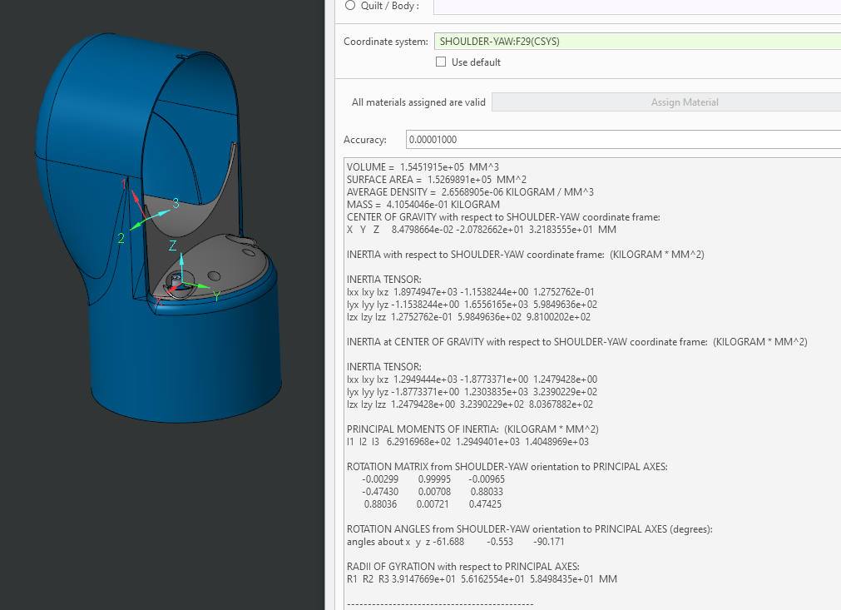

VOLUME = 1.5451915e+05 MM^3

SURFACE AREA = 1.5269891e+05 MM^2

AVERAGE DENSITY = 2.6568905e-06 KILOGRAM / MM^3

MASS = 4.1054046e-01 KILOGRAM

CENTER OF GRAVITY with respect to SHOULDER-YAW coordinate frame:

X Y Z 8.4798664e-02 -2.0782662e+01 3.2183555e+01 MM

INERTIA with respect to SHOULDER-YAW coordinate frame: (KILOGRAM * MM^2)

INERTIA TENSOR:

Ixx Ixy Ixz 1.8974947e+03 -1.1538244e+00 1.2752762e-01

Iyx Iyy Iyz -1.1538244e+00 1.6556165e+03 5.9849636e+02

Izx Izy Izz 1.2752762e-01 5.9849636e+02 9.8100202e+02

INERTIA at CENTER OF GRAVITY with respect to SHOULDER-YAW coordinate frame: (KILOGRAM * MM^2)

INERTIA TENSOR:

Ixx Ixy Ixz 1.2949444e+03 -1.8773371e+00 1.2479428e+00

Iyx Iyy Iyz -1.8773371e+00 1.2303835e+03 3.2390229e+02

Izx Izy Izz 1.2479428e+00 3.2390229e+02 8.0367882e+02

PRINCIPAL MOMENTS OF INERTIA: (KILOGRAM * MM^2)

I1 I2 I3 6.2916968e+02 1.2949401e+03 1.4048969e+03

ROTATION MATRIX from SHOULDER-YAW orientation to PRINCIPAL AXES:

-0.00299 0.99995 -0.00965

-0.47430 0.00708 0.88033

0.88036 0.00721 0.47425

ROTATION ANGLES from SHOULDER-YAW orientation to PRINCIPAL AXES (degrees):

angles about x y z -61.688 -0.553 -90.171

RADII OF GYRATION with respect to PRINCIPAL AXES:

R1 R2 R3 3.9147669e+01 5.6162554e+01 5.8498435e+01 MM

---------------------------------------------

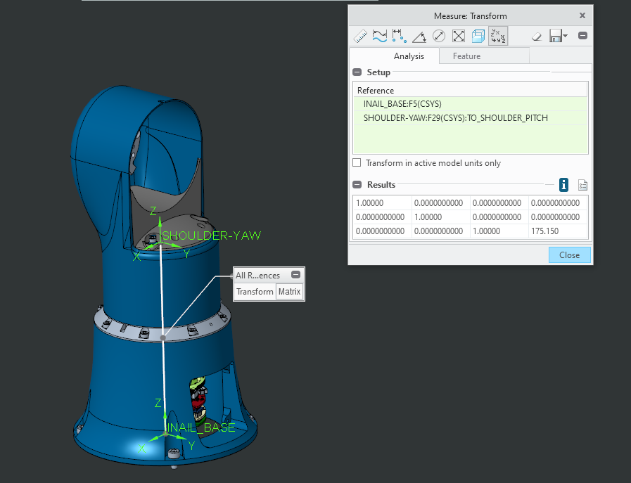

Shoulder –Pitch (Link2)

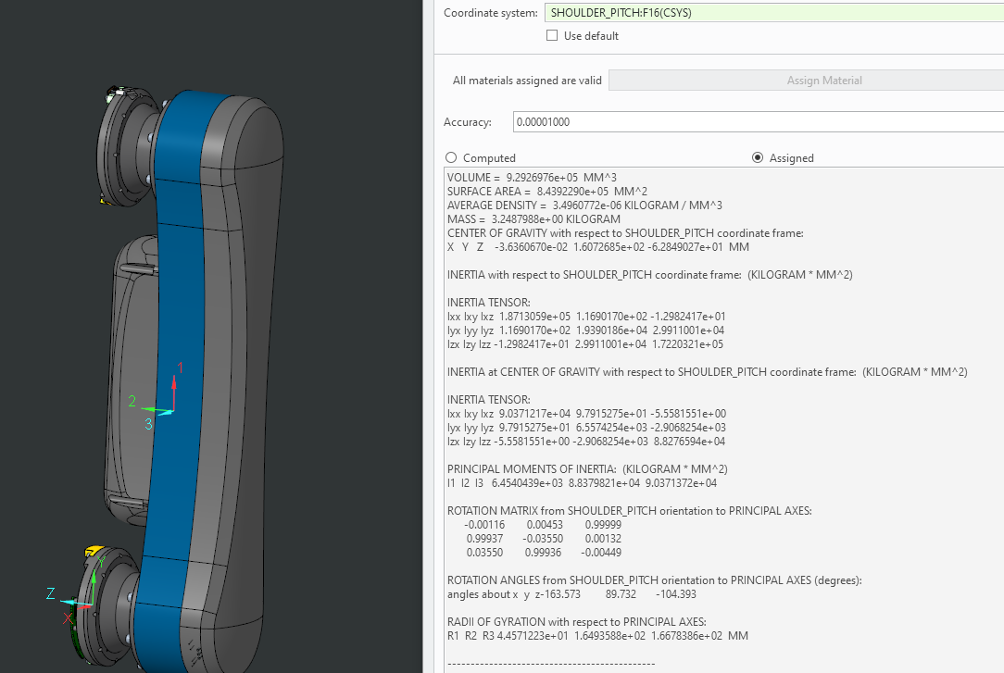

VOLUME = 9.2926976e+05 MM^3

SURFACE AREA = 8.4392290e+05 MM^2

AVERAGE DENSITY = 3.4960772e-06 KILOGRAM / MM^3

MASS = 3.2487988e+00 KILOGRAM

CENTER OF GRAVITY with respect to SHOULDER_PITCH coordinate frame:

X Y Z -3.6360670e-02 1.6072685e+02 -6.2849027e+01 MM

INERTIA with respect to SHOULDER_PITCH coordinate frame: (KILOGRAM * MM^2)

INERTIA TENSOR:

Ixx Ixy Ixz 1.8713059e+05 1.1690170e+02 -1.2982417e+01

Iyx Iyy Iyz 1.1690170e+02 1.9390186e+04 2.9911001e+04

Izx Izy Izz -1.2982417e+01 2.9911001e+04 1.7220321e+05

INERTIA at CENTER OF GRAVITY with respect to SHOULDER_PITCH coordinate frame: (KILOGRAM * MM^2)

INERTIA TENSOR:

Ixx Ixy Ixz 9.0371217e+04 9.7915275e+01 -5.5581551e+00

Iyx Iyy Iyz 9.7915275e+01 6.5574254e+03 -2.9068254e+03

Izx Izy Izz -5.5581551e+00 -2.9068254e+03 8.8276594e+04

PRINCIPAL MOMENTS OF INERTIA: (KILOGRAM * MM^2)

I1 I2 I3 6.4540439e+03 8.8379821e+04 9.0371372e+04

ROTATION MATRIX from SHOULDER_PITCH orientation to PRINCIPAL AXES:

-0.00116 0.00453 0.99999

0.99937 -0.03550 0.00132

0.03550 0.99936 -0.00449

ROTATION ANGLES from SHOULDER_PITCH orientation to PRINCIPAL AXES (degrees):

angles about x y z-163.573 89.732 -104.393

RADII OF GYRATION with respect to PRINCIPAL AXES:

R1 R2 R3 4.4571223e+01 1.6493588e+02 1.6678386e+02 MM

---------------------------------------------

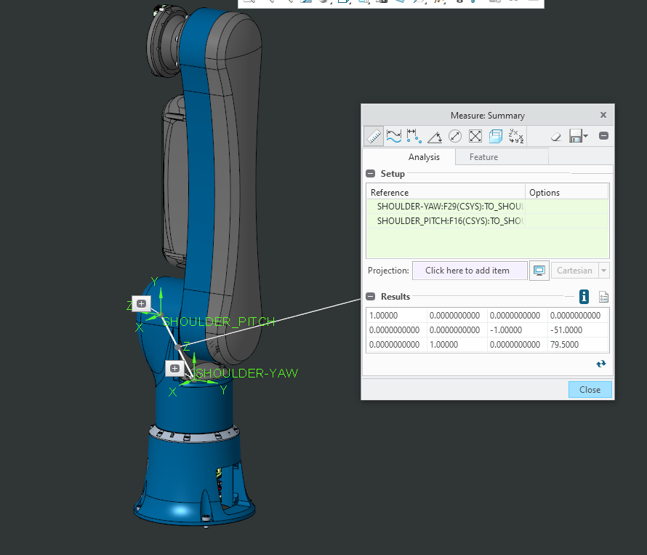

Elbow (Link3)

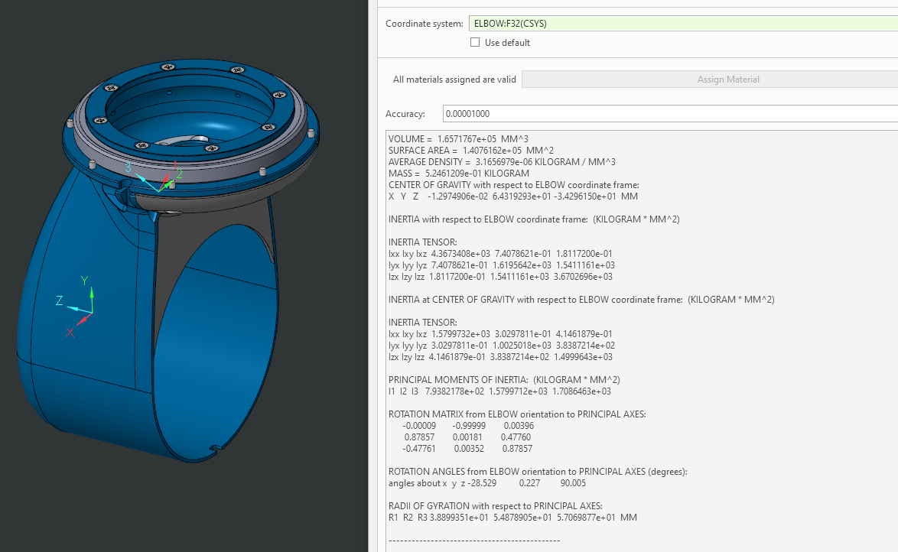

VOLUME = 1.6571767e+05 MM^3

SURFACE AREA = 1.4076162e+05 MM^2

AVERAGE DENSITY = 3.1656979e-06 KILOGRAM / MM^3

MASS = 5.2461209e-01 KILOGRAM

CENTER OF GRAVITY with respect to ELBOW coordinate frame:

X Y Z -1.2974906e-02 6.4319293e+01 -3.4296150e+01 MM

INERTIA with respect to ELBOW coordinate frame: (KILOGRAM * MM^2)

INERTIA TENSOR:

Ixx Ixy Ixz 4.3673408e+03 7.4078621e-01 1.8117200e-01

Iyx Iyy Iyz 7.4078621e-01 1.6195642e+03 1.5411161e+03

Izx Izy Izz 1.8117200e-01 1.5411161e+03 3.6702696e+03

INERTIA at CENTER OF GRAVITY with respect to ELBOW coordinate frame: (KILOGRAM * MM^2)

INERTIA TENSOR:

Ixx Ixy Ixz 1.5799732e+03 3.0297811e-01 4.1461879e-01

Iyx Iyy Iyz 3.0297811e-01 1.0025018e+03 3.8387214e+02

Izx Izy Izz 4.1461879e-01 3.8387214e+02 1.4999643e+03

PRINCIPAL MOMENTS OF INERTIA: (KILOGRAM * MM^2)

I1 I2 I3 7.9382178e+02 1.5799712e+03 1.7086463e+03

ROTATION MATRIX from ELBOW orientation to PRINCIPAL AXES:

-0.00009 -0.99999 0.00396

0.87857 0.00181 0.47760

-0.47761 0.00352 0.87857

ROTATION ANGLES from ELBOW orientation to PRINCIPAL AXES (degrees):

angles about x y z -28.529 0.227 90.005

RADII OF GYRATION with respect to PRINCIPAL AXES:

R1 R2 R3 3.8899351e+01 5.4878905e+01 5.7069877e+01 MM

---------------------------------------------

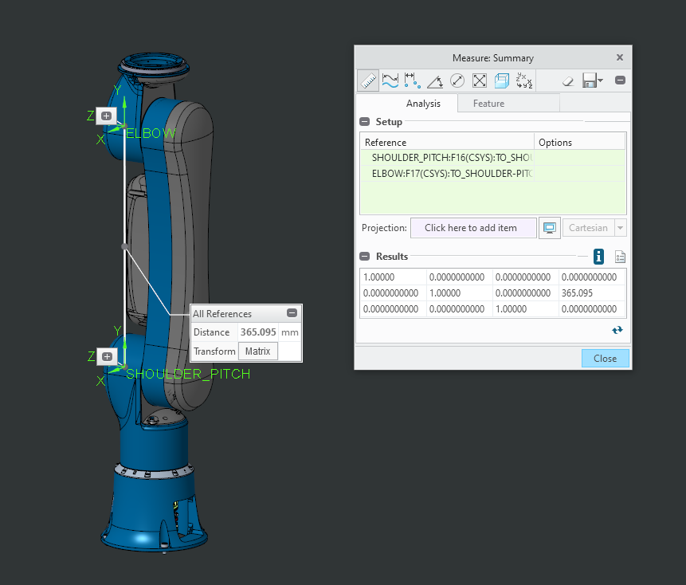

Forearm-Yaw (Link4)

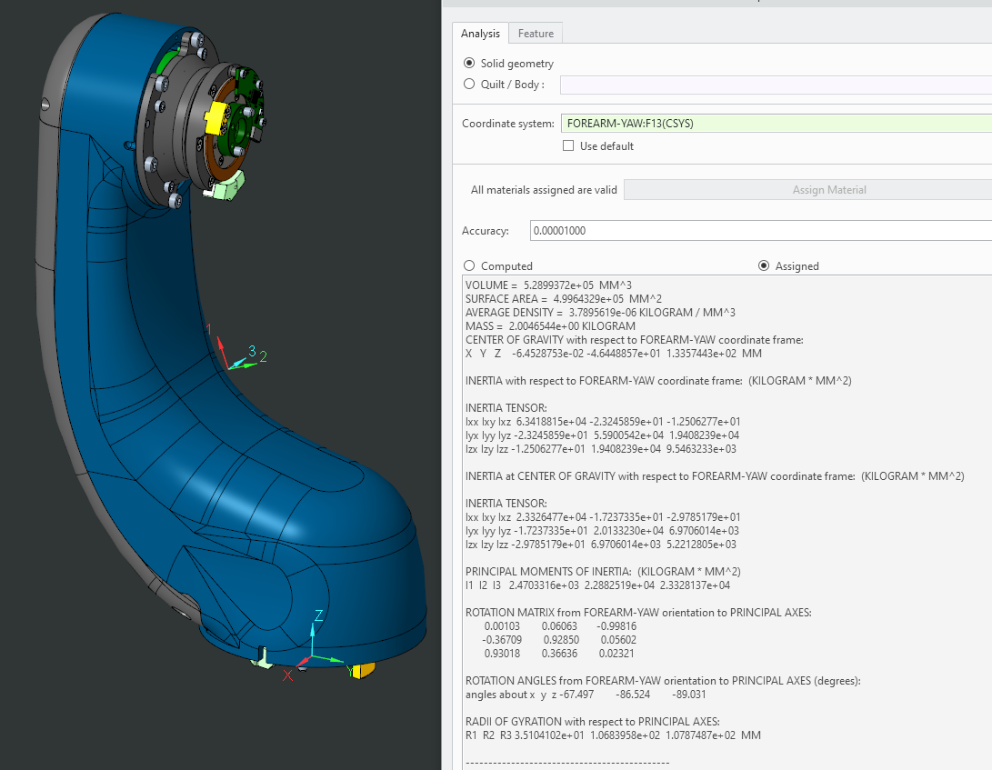

VOLUME = 5.2899372e+05 MM^3

SURFACE AREA = 4.9964329e+05 MM^2

AVERAGE DENSITY = 3.7895619e-06 KILOGRAM / MM^3

MASS = 2.0046544e+00 KILOGRAM

CENTER OF GRAVITY with respect to FOREARM-YAW coordinate frame:

X Y Z -6.4528753e-02 -4.6448857e+01 1.3357443e+02 MM

INERTIA with respect to FOREARM-YAW coordinate frame: (KILOGRAM * MM^2)

INERTIA TENSOR:

Ixx Ixy Ixz 6.3418815e+04 -2.3245859e+01 -1.2506277e+01

Iyx Iyy Iyz -2.3245859e+01 5.5900542e+04 1.9408239e+04

Izx Izy Izz -1.2506277e+01 1.9408239e+04 9.5463233e+03

INERTIA at CENTER OF GRAVITY with respect to FOREARM-YAW coordinate frame: (KILOGRAM * MM^2)

INERTIA TENSOR:

Ixx Ixy Ixz 2.3326477e+04 -1.7237335e+01 -2.9785179e+01

Iyx Iyy Iyz -1.7237335e+01 2.0133230e+04 6.9706014e+03

Izx Izy Izz -2.9785179e+01 6.9706014e+03 5.2212805e+03

PRINCIPAL MOMENTS OF INERTIA: (KILOGRAM * MM^2)

I1 I2 I3 2.4703316e+03 2.2882519e+04 2.3328137e+04

ROTATION MATRIX from FOREARM-YAW orientation to PRINCIPAL AXES:

0.00103 0.06063 -0.99816

-0.36709 0.92850 0.05602

0.93018 0.36636 0.02321

ROTATION ANGLES from FOREARM-YAW orientation to PRINCIPAL AXES (degrees):

angles about x y z -67.497 -86.524 -89.031

RADII OF GYRATION with respect to PRINCIPAL AXES:

R1 R2 R3 3.5104102e+01 1.0683958e+02 1.0787487e+02 MM

---------------------------------------------

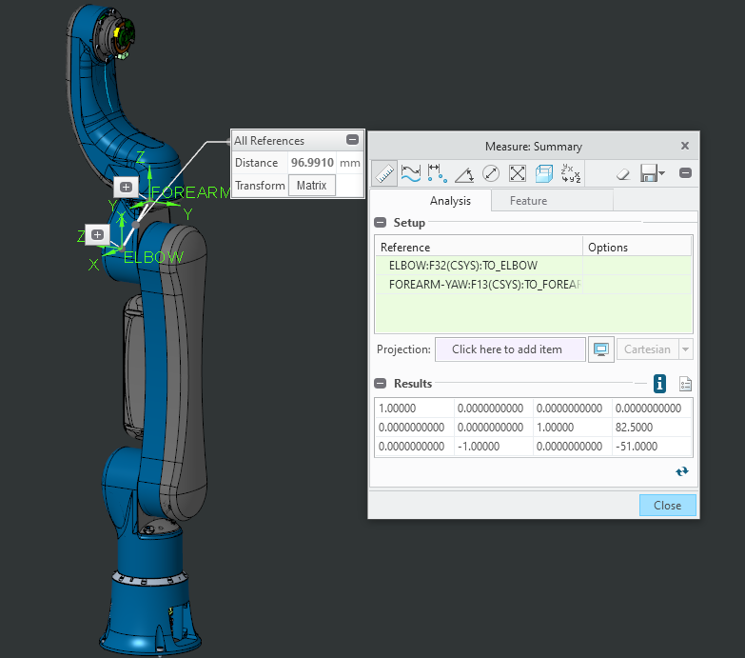

Wrist-Pitch (Link5)

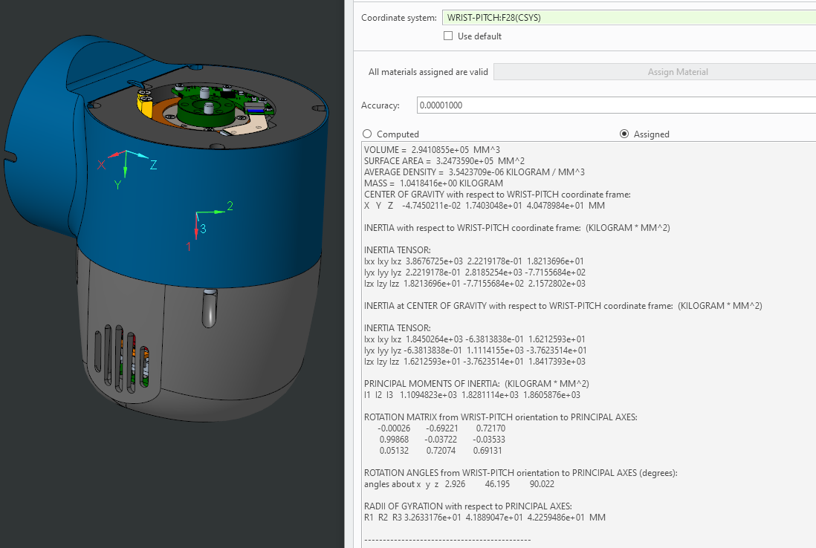

VOLUME = 2.9410855e+05 MM^3

SURFACE AREA = 3.2473590e+05 MM^2

AVERAGE DENSITY = 3.5423709e-06 KILOGRAM / MM^3

MASS = 1.0418416e+00 KILOGRAM

CENTER OF GRAVITY with respect to WRIST-PITCH coordinate frame:

X Y Z -4.7450211e-02 1.7403048e+01 4.0478984e+01 MM

INERTIA with respect to WRIST-PITCH coordinate frame: (KILOGRAM * MM^2)

INERTIA TENSOR:

Ixx Ixy Ixz 3.8676725e+03 2.2219178e-01 1.8213696e+01

Iyx Iyy Iyz 2.2219178e-01 2.8185254e+03 -7.7155684e+02

Izx Izy Izz 1.8213696e+01 -7.7155684e+02 2.1572802e+03

INERTIA at CENTER OF GRAVITY with respect to WRIST-PITCH coordinate frame: (KILOGRAM * MM^2)

INERTIA TENSOR:

Ixx Ixy Ixz 1.8450264e+03 -6.3813838e-01 1.6212593e+01

Iyx Iyy Iyz -6.3813838e-01 1.1114155e+03 -3.7623514e+01

Izx Izy Izz 1.6212593e+01 -3.7623514e+01 1.8417393e+03

PRINCIPAL MOMENTS OF INERTIA: (KILOGRAM * MM^2)

I1 I2 I3 1.1094823e+03 1.8281114e+03 1.8605876e+03

ROTATION MATRIX from WRIST-PITCH orientation to PRINCIPAL AXES:

-0.00026 -0.69221 0.72170

0.99868 -0.03722 -0.03533

0.05132 0.72074 0.69131

ROTATION ANGLES from WRIST-PITCH orientation to PRINCIPAL AXES (degrees):

angles about x y z 2.926 46.195 90.022

RADII OF GYRATION with respect to PRINCIPAL AXES:

R1 R2 R3 3.2633176e+01 4.1889047e+01 4.2259486e+01 MM

---------------------------------------------

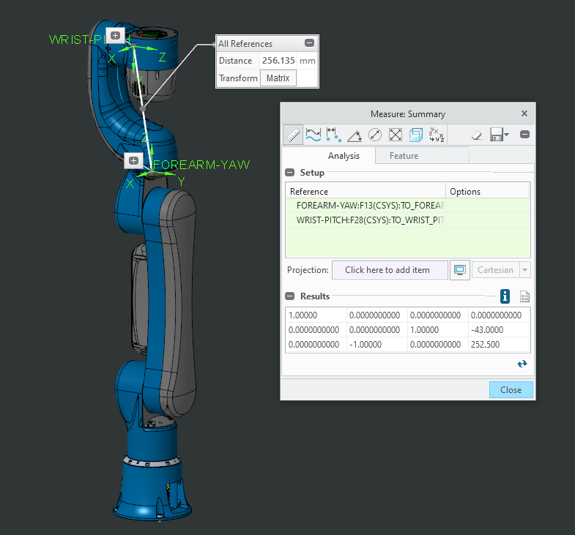

Wrist-Roll (Link6)

